Review for Test on Units #1 -#5

**Common Core Algebra II**

1. Determine for each of the following graphed relationships illustrates a **function,** a **one-to-one function,** or **neither.**

***y***

***x***

***y***

***x***

***y***

***x***

(a) (b) (c)

2. Which of the graphs from #1 has an inverse which is also a function? Justify your answer.

3. Complete the following tables to construct the described relationship.

One-to-one function

Function that is not one-to-one

Not a function

|  |  |
| --- | --- |
| *x* | *y* |
| -2 | 11 |
| 0 | 7 |
| 2 | 14 |
| 4 | 23 |
|  |  |

|  |  |
| --- | --- |
| *x* | *y* |
| -2 | 11 |
| 0 | 7 |
| 2 | 14 |
| 4 | 23 |
|  |  |

|  |  |
| --- | --- |
| *x* | *y* |
| -2 | 11 |
| 0 | 7 |
| 2 | 14 |
| 4 | 23 |
|  |  |

4. State the domain and range for each function below.

*y*

*x*

*y*

*x*

*y*

*x*

(a) (b) (c)

D_________________

R_________________

D_________________

R_________________

D_________________

R_________________

5. Determine the domain of each of the functions from its formula below.

(a)  (b)  (c) 

(d)  (e)  (f) 

(g)  (h)  (i) 

6. The function  maps the domain given by the set . Determine the range of .

7. Fully expand the expression 

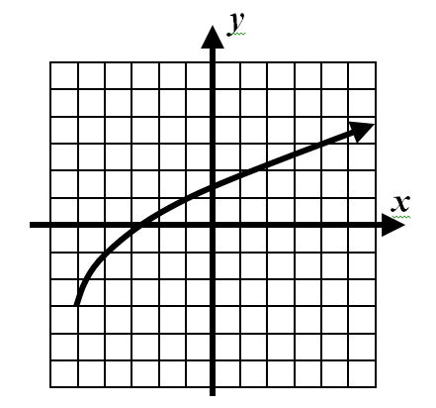

8. The graph of the function  is shown below.

What is the value of 

9. The function  is shown graphed to the right. Answer the following questions based on this graph.

*y*

*x*

1. What is the domain of the function?
2. What is the domain of the function?



1. What is the range of the function?
2. Evaluate 

(d) What value(s) of *x* solve the equation ?

(f) Over what intervals is the function decreasing?

(e) What value(s) of *x* solve the equation 

(i) State the values of the relative maximum(s) and relative minimum(s).

(g) Over what intervals is the function increasing?

(j) State the value of the absolute maximum and absolute minimum.

(h) Over what interval(s) is 

10. For the function it is known that   and. Determine if the following

statements are TRUE or FALSE

(1) The function has a *y*-intercept of *d.*

(2) The function has an *x*-intercept of *d.*

(3) The inverse of the function passes through the point 

(4) The inverse of the function passes through the point 

***y***

***x***

11. The function  is shown graphed to the right.

Calculate the **average rate of change** for

the function over each of the intervals.

(i)  (ii) (iii) 

12. Consider the two functions  and .

(a) Calculate the average rate of change for both functions over the following intervals. Do your work carefully and show the calculations that lead to your answers.

(i)  (ii) 

(b) What do you notice about the average rate of change for  and ?

13. For the function  given in the table below, calculate the average rate of change for each of the following intervals.

|  |  |  |  |  |  |
| --- | --- | --- | --- | --- | --- |
| *x* |  |  | 3 | 5 | 8 |
|  | 9 |  | 14 | 10 | 3 |

(a)  (b)  (c) 

14. The table below gives the amount of Waste , *W,* in millions of tons, produced in the US in the year *t*.

|  |  |  |  |  |  |  |  |
| --- | --- | --- | --- | --- | --- | --- | --- |
| T  (year) | 1980 | 1985 | 1990 | 1995 | 2000 | 2005 | 2010 |
| *W*  *(millions of tons)* | 80 | 115 | 125 | 135 | 157 | 170 | 190 |

(a) Determine the average rate of change of the waste produced from 1980 to 1985

(b) Determine the average rate of change of the waste produced from 1985 to 1995

(d) Determine the average rate of change of the waste produced from 1985 to 2010

(c) Determine the average rate of change of the waste produced from 1990 to 2005

15. Write the equation of a line that passes through the points (-9, 13) and (3,5) in both slope-intercept and

point-slope form.

16. Write the equation of the line that is perpendicular to the line  and passes through the point

(5, -2).

17. A car traveling at a constant speed of 56 miles per hour has a distance of *y* miles from

Poughkeepsie, NY.

(a) If the car starts out 22 miles from Poughkeepsie (b) Find the equation of the inverse of the

write an equation to model this scenario. Use function you found in part a.

*x* to represent the time, in hours, the car has

been traveling.

(c) Evaluate the inverse for an input of  (d) What does the answer you found in part c

represent?

18. The graph and its inverse are always symmetric across what line? __________________

19. If the *y*-intercept of a linear function is 6, then we know what about its inverse? _______________

20. Find the inverseof each function below:

a.  b.  c.  d. 

e. 

21. Find the equation for the inverse of the following functions and name a point that lies on the graph of its inverse.

(a)  (b) 

22. Which of the following points lies on the inverse of 

(1) (2, -1) (2)  (3) (-1, 2) (4) (-2, 1)

23. For each of the following equations, find the *y*-intercept of the inverse:

(a)  (b)  (c) 

24. Solve the system of equations shown below. Show each step in your solution process.

(a) 

(b) 

25. At the annual holiday festival a local charity was selling hot dogs, soda, and popcorn. Sally bought 2

hot dogs, one soda and one bag of popcorn and spent $13. Andrew bought one hot dog, 2 sodas and

one bag of popcorn and spent $11. Manuel bought one hot dog, 3 sodas and 3 bags of popcorn and

spent $19. Find the cost of each item.

26. On the accompanying set of axis graph  and .

*y*

*x*

27. State the domain and range of any function in the form of when .

Domain: _________________ Range: _________________

28. Sketch the graphs of the following on the accompanying axis. Make sure

to label the *y-intercept* and the *horizontal asymptote*.

a.  b. 

*x*

*y*

*x*

*y*

29. ***Find the value of x that satisfy each of the following:***

  

30. Rewrite each of the following expressions without rational or negative exponents

(a)  (b)  (c)  (d) 

31. Given  evaluate each of the following:

a.  ________ b.  ________ c.  ________ d.  ________

32. Without a calculator match each exponential formula to one of the graphs.

(A)  (C)  (A)  (C) 

(B)  (D)  (B)  (D) 

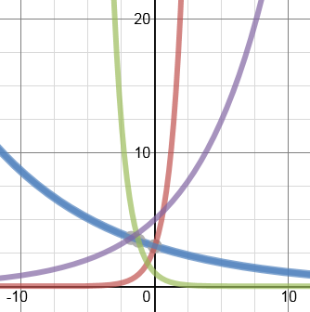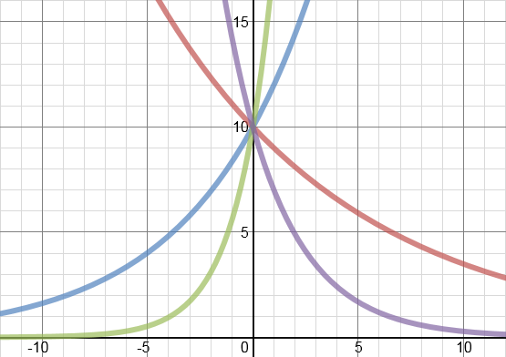

33. In 1990, the Peru’s daily inflation rate was 1.2% per day. What was the corresponding annual inflation

rate? Give your answer to the nearest tenth of a percent.

34. The price of a certain item increases due to inflation. Let  give the price of the item

as a function of time in years, with  in 1970.

(a) What is the annual inflation rate? (b) What is the monthly inflation rate?

35. Kevin buys a new Ipod for $250 and finds two years later when he wants to sell it that it is only worth

$100. Find a formula for the value of the Ipod if the value decreases exponentially.

36. The Internet is a network of computers allowing the transfer of information. The graph below gives *N*,

the number of packets of information sent per month across the Internet (in billions), as a function of *t*,

the number of years since 1990. Find a possible formula for .

1

2

3

4

10

20

30

40

*N,* information packets per month (billions)

*t,* years since 1990

37. The population of a city is increasing exponentially. In 1998 the city had a population of 30,000 and in

2002 the population was 48,000.

(a) Give a formula for the population *P*, of the city as a function of time, *t*, in years since 1996.

(b) Determine *algebraically* when the population will be 100,000.

38. Joe bought a car for $8500. The car depreciates in value at a rate of 12% per year.

(a) Write an equation that represents the value of the car after *t* years.

(b) How much is the car worth after Joe owned it for 4 years?

(c) When, to the nearest hundredth of a year, will the call be worth only $500?

39. Anna deposits $13000 into an account with an annual interest rate of 7% per year. What is Anna’s

***profit*** after 8 years?

40. Daniel deposits $1400 into an account with an annual interest rate of 8% compounded quarterly. How

long will it take for Daniel to have $4000 in his account?

41. Matulio invests $7000 into a bank that guarantees 3% annual interest rate, compounded monthly. In

how many years, *to the nearest hundredth*, will Matulio’s money triple?

42. ***For each of the following exponential functions below: a. identify the initial value, b. tell if the***

***function is increasing or decreasing AND why, and c. tell the percent of increase or decrease***.

 

43. Which of the following is ***equivalent*** to  43. ______

(1)  (2)  (3)  (4) 

44. Which of the following is the ***inverse*** of  44. ______

(1)  (2)  (3)  (4) 

45. ***Evaluate each of the following:***

(a)  (b)  (c)  (d) 

46. S***olve each of the following equations for x:***

(a)  (b)  (c)  (d) 

(e)  (f)  (g)  (h) 

*x*

*y*

47. On the accompanying grid graph 

48. State the domain and range of 

Domain: _________________ Range: _________________

49. What is the intersection point of 

50. Determine the natural domain of each of the following log equations.

(a)   (b)   

51. Solve each of the following equations for *x*. Round answers to the *nearest hundredth*.

(a)  (b)  (c) 

(d)  (e)  (d) 

52. Suppose you deposit $3500 into a savings account paying 3% a year compounded continuously.

(a) Write and equation to model the amount of money you have at any given time.

(b) How much will you have in the account in 7 years?

(c) When will your account double?

53. Find the *x* and *y* intercepts of  Give exact answers.

54. A population of turtles on a island can be modeled by the equation  where *t* represents

the number of years since Ethan started watching them in 2007

(a) How many turtles were there in 1998?

(b) How many turtles were there in 2003?

(c) During what year will the number of turtles first hit 1000?

55. At 4 AM a body is found in a park. The police measure the body’s temperature to be  At 5 AM,

the medical examiner arrives and determines the temperature to be  Assuming the temperature

of the park was at a constant  how long has the victim been dead?

56. Mabel takes her hot buns out of the oven with an initial temperature of  After 15 minutes the

temperature of her buns is  If Mabel keeps her kitchen at a constant  and doesn’t want to

serve her buns until they are cooled down to  in how many minutes, to *the nearest hundredth*,

will her buns to ready to serve?

57. Determine the value of  in each of the sequences defined below:

(a)  (b) 

58. Determine whether each of the following sequences is arithmetic, geometric, or neither. If the sequence is arithmetic or geometric, state its *d* or *r* value, respectively.

(a)  (b)  (c) 

59. Find the indicated term of each sequence.

(a)  (b) 

60. What is the value of written as a trinomial in simplest form?

61. The expression  is equivalent to:

(1)  (2)  (3)  (4) 

62. Find the sum of the geometric series given by 

63. A geometric series whose first term is 10 and whose common ratio is 2 sums to 20,470. How many terms are in this sum?

64. Mr. Hinkley is trying to save $40,000 to buy a boat to use when he retires from work. Each year he saves $1,500 on January 1st and earns 4% annual interest at the end of each year. If this is repeatedly done, will he have enough money for the boat at the beginning of the 20th year of saving?

65. Monthly mortgage payments can be found using the formula below:

 

The Banks family would like to borrow $120,000 to purchase a home. They qualified for an annual interest rate of 4.8%. Algebraically determine the *fewest* number of whole years the Banks family would need to include in the mortgage agreement in order to have a monthly payment of not more than $720.